Topic 5.4

TRANSITION METALS

Electronic Configuration
Oxidation States
Complex Ions
Catalysis
Redox Chemistry of Transition Metals
Redox Titrations

INTRODUCTION TO TRANSITION ELEMENTS

A d-block element is an element which has at least one s-electron and at least one d-electron but no p-electrons in its outer shell.

- Electronic configuration

The outer electronic configuration of elements in the first row of the d-block is as follows:
4s 3d

Sc | [Ar] |  | ↑↓ |  | ↑
Ti | [Ar] |  | ↑↓ |  | ↑ | ↑
V | [Ar] |  | ↑↓ |  | ↑ | ↑ | ↑
Cr | [Ar] |  | ↑ |  | ↑ | ↑ | ↑ | ↑ | ↑
Mn | [Ar] |  | ↑↓ |  | ↑ | ↑ | ↑ | ↑ | ↑
Fe | [Ar] |  | ↑↓ |  | ↑↓ | ↑ | ↑ | ↑ | ↑
Co | [Ar] |  | ↑↓ |  | ↑↓ | ↑↓ | ↑ | ↑ | ↑
Ni | [Ar] |  | ↑↓ |  | ↑↓ | ↑↓ | ↑↓ | ↑ | ↑
Cu | [Ar] |  | ↑ |  | ↑↓ | ↑↓ | ↑↓ | ↑↓ | ↑↓
Zn | [Ar] |  | ↑↓ |  | ↑↓ | ↑↓ | ↑↓ | ↑↓ | ↑↓

Note the unusual structures of chromium and copper. The 4s and 3d subshells are very similar in energy and therefore it is easy to promote electrons from the 4s into the 3d orbitals.

In chromium the 4s¹3d⁵ structure is adopted because the repulsion between two paired electrons in the 4s orbital is more than the energy difference between the 4s and 3d subshells. It is thus more stable to have unpaired electrons in the higher energy 3d orbital than paired electrons in the lower energy 4s orbital.

In copper and zinc the 3d subshell is actually lower in energy than the 4s subshell. The 3d orbitals are thus filled before the 4s orbital. Thus copper adopts a 4s¹3d¹⁰ configuration.

In all ions of d-block elements, the 3d subshell is lower in energy than the 4s subshell so the 4s electrons are always removed first. 3d electrons are only removed after all 4s electrons have been removed.

Some examples of electronic configurations of transition metal ions are shown below:

4s 3d
V²⁺ | [Ar] |  |  |  | ↑ | ↑ | ↑
Cr³⁺ | [Ar] |  |  |  | ↑ | ↑ | ↑
Mn²⁺ | [Ar] |  |  |  | ↑ | ↑ | ↑ | ↑ | ↑

- Oxidation states

The oxidation state formed by an element in its compounds is determined by the maximum number of electrons it can lose without requiring so much energy to remove the electrons that the energy cannot be recovered in bonding.

s-block elements only form one stable oxidation state in their compounds. They lose all their valence electrons easily but cannot lose any more electrons since there is a large amount of energy required to remove the electrons from the inner shell.

This jump in energy is best shown graphically:

Eg Na Eg Mg

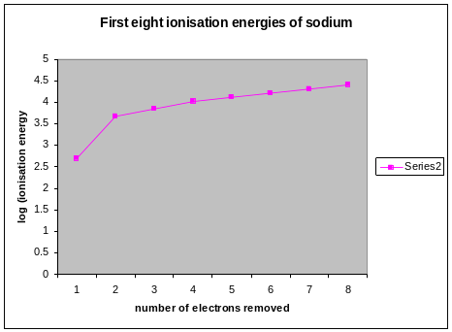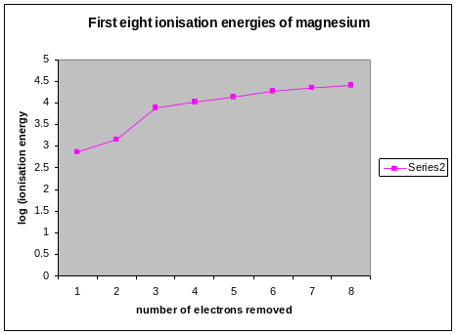

Na always adopts the +1 oxidation state in its compounds because there is a large jump between the first and the second ionisation energies.
Mg always adopts the +2 oxidation state in its compounds because there is a small jump between the first and the second ionisation energies but a very large jump between the second and third ionisation energies.

In the d-block elements, however, there are often a large number of valence electrons and removing them all would require so much energy that it would be unfeasible. It is usually only possible to remove some of the valence electrons. All d-block elements can give up their 4s electrons fairly easily but the d-electrons are harder to remove.
Moreover, since the successive ionisation energies of d-electrons increase steadily, it is difficult to predict how many can be lost.

This effect can be shown graphically by considering the successive ionisation energies of an element such as manganese:

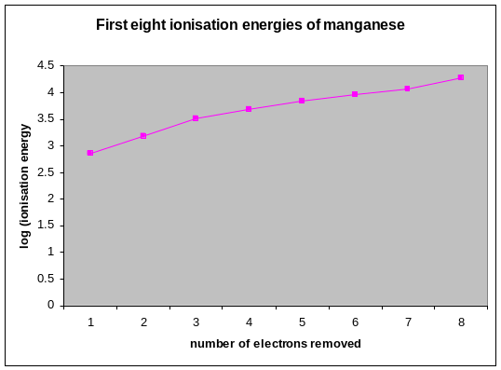

The ionisation energies increase steadily after the removal of the 4s electrons. It turns out that the energy required to remove the 3d electrons is sometimes recovered in bonding, but not always. The number of 3d electrons removed thus varies from compound to compound

d-block metals are thus able to adopt a variety of oxidation states.

The oxidation states most commonly formed by the first-row d-block elements are as follows:

Sc: +3 only (d⁰)
Ti: +3 (d¹), +4 (d⁰)
V: +2 (d³), +3 (d²), +4 (d¹), +5 (d⁰)
Cr: +3 (d³), +6 (d⁰)
Mn: +2 (d⁵), +3 (d⁴), +4 (d³), +6 (d¹), +7 (d⁰)
Fe: +2 (d⁶), +3 (d⁵)
Co: +2 (d⁷), +3 (d⁶)
Ni: +2 (d⁸)
Cu: +1 (d¹⁰), +2 (d⁹)
Zn: +2 only (d¹⁰)

It is sometimes possible to remove all 3d electrons to form a dº configuration. However for elements beyond manganese it is unusual to find an oxidation state containing fewer than 5 3d electrons. The d⁵ configuration is quite stable because paired d-electrons can be removed to reach d⁵ but unpaired electrons must be removed to reach d⁴. Unpaired electrons are harder to remove because there is less repulsion between the electrons.

Note that scandium only forms +3 ions (d⁰). This is because the low effective nuclear charge on scandium enables all three valence electrons to be removed fairly easily.

Note also that zinc only forms +2 ions (d¹⁰). This is because the high effective nuclear charge on zinc prevents any 3d electrons from being removed.

All the other elements form at least one stable ion with partially filled d-orbitals, and it is this property which defines a transition metal.

A transition metal is a metal which forms at least one stable ion with partially filled d-orbitals.

Since zinc and scandium do not share this property, they are not transition metals, and indeed do not show many of the properties generally attributed to transition metals. They are however still classified as d-block elements.

The first row d-block elements which are also transition metals are therefore titanium, vanadium, chromium, manganese, iron, cobalt, nickel and copper.

COMPLEX IONS

A complex ion is an ion comprising one or more ligands attached to a central metal cation by means of a dative covalent bond.

A ligand is a species which can use its lone pair of electrons to form a dative covalent bond with a transition metal. Examples of ligands are H₂O, NH₃, Cl⁻, OH⁻, CN⁻,

Cations which form complex ions must have two features:

- they must have a high charge density, and thus be able to attract electrons from ligands.

- they must have empty orbitals of low energy, so that they can accept the lone pair of electrons from the ligands.

Cations of d-block metals are small, have a high charge and have available empty 3d and 4s orbitals of low energy. They thus form complex ions readily.

The number of lone pairs of electrons which a cation can accept is known as the coordination number of the cation. It depends on the size and electronic configuration of that cation, and also on the size and charge of the ligand. 6 is the most common coordination number, although 4 and 2 are also known.

Examples of complex ions are [Fe(H₂O)₆]²⁺, [CoCl₄]²⁻, [Cu(NH₃)₄(H₂O)₂]²⁺. Note that the formula of the ion is always written inside square brackets with the overall charge written outside the brackets.

- Shapes of complex ions

6-coordinate complexes are all octahedral, and are formed with small ligands such as H₂O and NH₃. They can thus be drawn as follows:

[Fe(H₂O)₆]²⁺ [Cr(NH₃)₆]³⁺ [Cu(NH₃)₄(H₂O)₂]²⁺

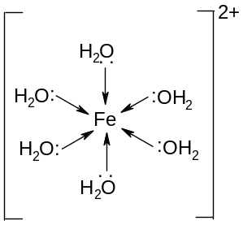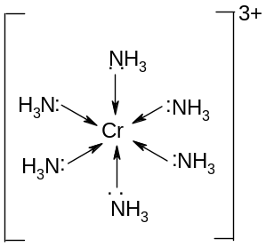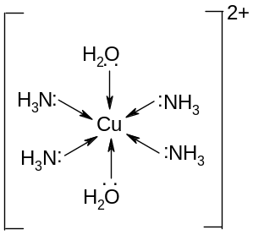

4-coordinate complexes are generally tetrahedral, and are formed with larger ligands such as Cl⁻. Larger ligands cannot fit around the transition metal so easily and hence form smaller complexes. They can be drawn as follows:

[CoCl₄]²⁻

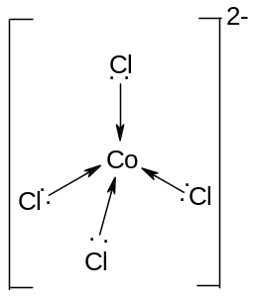

2-coordinate complexes are in general linear, and are formed with Ag⁺ ions. They can be drawn as follows:

[Ag(NH₃)₂]⁺

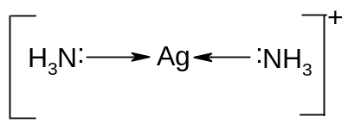

The rules covering the likely coordination number of transition metal complexes are:

a) Silver ions form linear complexes with a coordination number of 2;

b) Chloride ions and other large ions form tetrahedral complexes with a coordination number of 4;

c) Most other transition metal complexes are octahedral with a coordination number of 6.

- Representation of metal salts

When metal ions are in solution, they are usually represented as the simple ion, such as Fe²⁺(aq), Co²⁺(aq), Cr³⁺(aq) or Fe²⁺(aq).
This is, however, a simplified representation as all d-block cations and many other cations with high polarising power exist as the hexaaqua complex, eg [Fe(H₂O)₆]²⁺.

Eg FeSO₄(aq) consists of [Fe(H₂O)₆]²⁺ and SO₄²⁻ ions
Eg Fe₂(SO₄)₃(aq) consists of [Fe(H₂O)₆]³⁺ and SO₄²⁻ ions
Eg CuCl₂(aq) consists of [Cu(H₂O)₆]²⁺ and Cl⁻ ions

Many complex ions exist in the solid state. In these cases the ligands are often written after the rest of the compound, seperated by a dot:

Eg [Fe(H₂O)₆]SO₄(s) is generally written FeSO₄.6H₂O(s)
Eg [Cr(H₂O)₆]Cl₃(s) is generally written CrCl₃.6H₂O(s)

The dot does not always, however, mean that there are ligands present; some salts contain water of crystallisation, where the water is not a ligand but a link between the ions.

Eg in Na₂CO₃.10H₂O, the water molecules are not behaving as ligands, but as water molecules of crystallisation.

Eg in CuSO₄.5H₂O, four of the water molecules are behaving as ligands, and the fifth as a water molecule of crystallisation: [Cu(H₂O)₄]SO₄.H₂O

- Chemical properties of complex ions

a) polarising power

The effect of ligands in a complex ion is to significantly stabilise the metal cation by increasing its size and hence reducing its polarising power. Many compounds which are covalent in the anhydrous state are actually ionic in the hydrated state:

Eg FeCl₃(s) is covalent but FeCl₃.6H₂O(s) is ionic.
Eg AlCl₃(s) is covalent but AlCl₃.6H₂O(s) is ionic.

b) precipitation reactions

The properties of anions are also changed if they are behaving as ligands in a complex ion. In particular, they are much less readily precipitated by cations.
For example, AgNO₃(aq) will form a precipitate of AgCl if added to a solution of copper (II) chloride, [Cu(H₂O)₄]Cl₂ but not from sodium tetrachlorocobaltate (II), Na₂[CoCl₄]. BaCl₂(aq) will form a precipitate of BaSO₄ if added to a solution of [Cr(H₂O)₅Cl]SO₄ but not with [Cr(H₂O)₅SO₄]Cl.

c) heating

The properties of molecules also changes if they are behaving as ligands. In particular, they are much less readily removed by heating.
For example, Na₂CO₃.10H₂O(s) can be dehydrated to Na₂CO₃(s) by gentle heating at 50ºC.
FeSO₄.6H₂O(s), however, can only be dehydrated to FeSO₄(s) by strong heating at 150ºC, since the water is strongly bonded to the Fe²⁺ as a ligand.
CuSO₄.5H₂O(s) can be dehydrated to CuSO₄.4H₂O(s) by gentle heating at 50ºC, and to CuSO₄ by strong heating at 100ºC. One of the water molecules is a molecule of crystallisation but the others are ligands.

- Polydentate ligands

Some ligands are capable of forming more than one dative covalent bond per ligand.
Examples are ethanedioate (C₂O₄²⁻) and 1,2-diaminoethane (H₂NCH₂CH₂NH₂), both of which donate 2 lone pairs per ligand and are said to be bidentate.

One unusual ligand, known as edta⁴⁻, can form 6 dative covalent bonds per ligand. It is thus said to be hexadentate.

Ligands such as H₂O, Cl⁻ and CN⁻ form only one dative covalent bond per ligand and are said to be unidentate.

With polydentate ligands it often appears that the coordination number of the complex is 1 or 3, when in fact the coordination number is 6 as normal - it is just that each ligand is bonded twice. Some examples of these complex ions are shown below:

[Fe(C₂O₄)₃]³⁻ [Cr(H₂NCH₂CH₂NH₂)₃]³⁺ [Cu(edta)]²⁻

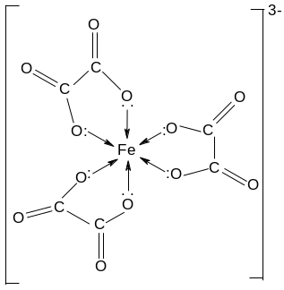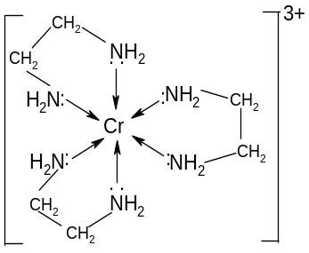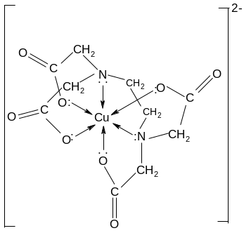

5. Coloured ions

a) Formation of coloured ions

When a cation forms a complex ion, the incoming ligands repel the electrons in the atom, and thus they are raised in energy. Some of the d-orbitals, however, are repelled more than others and the result is that the d-orbitals are split into 2 groups of orbitals, with three orbitals being slightly lower in energy than the other two:

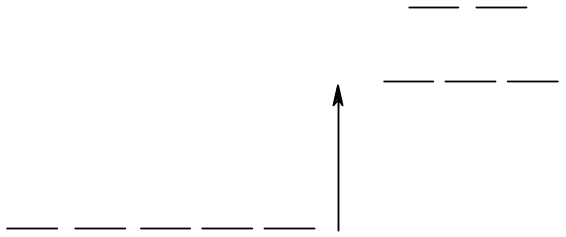

The difference in energy between these groups of orbitals is similar to the energy of visible light. The energy of the light is related to the frequency of the light by the equation E = hf.
If these d-orbitals are partially filled, some of the electrons in the lower energy orbitals are excited into the higher energy orbitals, and in doing so absorb the light that corresponds to that frequency. The resultant light is deficient in the light of that frequency and thus appears coloured.

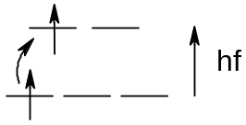

Transition metal ions are coloured because d-electrons can absorb light and get excited into higher energy d-orbitals. The resultant light is thus missing certain frequencies and is hence coloured.

Note that two criteria must be satisfied if the ion is to be coloured:

- there must be a splitting of the d-orbitals. This only happens in the presence of ligands and thus only complex ions are coloured. Anhydrous ions do not have split d-orbitals and so cannot aborb light in the visible spectrum and are thus white.
Eg anydrous CuSO₄ (d⁹) is white but hydrated CuSO₄.5H₂O is blue.

- the d-orbitals must be partially filled. If the d-orbitals are empty (Eg Sc³⁺, Al³⁺) then there are no electrons which can be excited into the higher energy d-orbitals and the ions will be colourless. If the d-orbitals are full (Eg Cu⁺, Zn²⁺) then there are no empty orbitals into which the electrons can be excited and the ions will be colourless.

b) Use of colour in analysis of complex ions

The colour of a complex ion depends on:
- the ligand
- the coordination number
- the oxidation state of the metal
- the identity of the metal

As transition metal ions can show a huge variety of colours, it is often possible to identify a complex ion simply by its colour.

It is also possible to determine the concentration of a solution containing a coloured ion using a technique called ultraviolet and visible spectrophotometry. As the absorbance of a solution is proportional to its concentration, the concentration of any solution can be determined by comparing its absorbance to the absorbance of a solution of known concentration.

The technique can be summarised as follows:

a) A solution containing a known concentration of the ion is prepared, and a suitable ligand is added in excess in order to intensify the colour (thiocyanate ions, SCN⁻, are often used for this purpose).

b) A sample of the solution is placed into a cuvette in a colorimeter and the filter which gives the maximum absorbance is selected.

c) The absorbance of the solution is recorded.

d) This process is repeated using a range of other known concentrations, and a graph is plotted of absorbance against concentration.

d) The solution of unknown concentration is mixed with an excess of the same ligand to intensify the colour.

e) The absorbance of the solution of unknown concentration is then recorded using the same filter.

f) The concentration of this solution can then be determined from the concentration-absorbance graph.

6. Other applications of transition metal complexes

- haemoglobin

Another important complex ion involving multidentate ligands is haemoglobin.

Haem is a complex ion consisting Fe²⁺ and a complex tetradentate ligand called porphyrin. The complex is generally found with a protein called globin, which provides the fifth coordinate bond, and a molecule of oxygen which forms the sixth bond. The complete six coordinate complex is called haemoglobin. This structure is responsible for carrying oxygen in the blood throughout the human body.

Fe²⁺ + porphyrin → haem
haem + globin + O₂ → haemoglobin

Carbon monoxide is a similar size and shape to oxygen and forms a much stronger bond with the iron. It thus diplaces the oxygen from the complex and reduces the blood’s ability to carry oxygen. It is thus a very poisonous gas.

- cisplatin

The square planar complex cisplatin has the following structure:

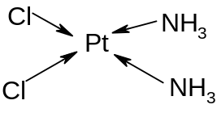

It kills cancerous cells and now widely used in cancer treatment.

- Tests for aldehydes and halide ions

Diammine silver (I) has the formula [Ag(NH₃)₂]⁺ and is the active ion in Tollen’s reagent.

It is reduced to silver by reducing sugars and aldehydes (but not ketones). It produces a characteristic silver mirror on the side of the test-tube and this is used as the basis of the test for aldehydes.

It is also formed in the test for halide ions in solution. The silver halides are insoluble in water but AgCl and AgBr will dissolve in ammonia due to the formation of the diammine silver complex:
AgCl(s) + 2NH₃(dilute) → [Ag(NH₃)₂]⁺(aq) + Cl⁻(aq)
AgBr(s) + 2NH₃(conc) → [Ag(NH₃)₂]⁺(aq) + Br⁻(aq)

- photography

Silver bromide, AgBr, is the substance on photographic film. In the presence of light, it decomposes into silver and bromine:
2AgBr → 2Ag(s) + Br₂(l).

The unreacted AgBr is removed when sodium thiosulpate is added. This forms a complex with the AgBr and washes it off the film, leaving only the silver metal on the film. The result is the negative image.
AgBr(s) + 2S₂O₃²⁻(aq) → [Ag(S₂O₃)₂]³⁻(aq) + Br⁻(aq)

- electroplating

Metals such as silver and gold generally occur native, but in very impure form. They can be extracted using cyanide ions which form stable complexes with silver and gold.
The Ag is oxidized to Ag⁺ and then complexed as [Ag(CN)₂]⁻.

This complex is widely used in electroplating. To coat another object with silver, place the metal object to be coated at the cathode and use [Ag(CN)₂]⁻ as the electrolyte. The complex breaks up, Ag⁺ ions move to the cathode and the object is coated with a layer of silver.

TRANSITION METALS AS CATALYSTS

The ability of transition metals to form more than one stable oxidation state means that they can accept and lose electrons easily. This enables them to catalyse certain redox reactions. They can be readily oxidised and reduced again, or reduced and then oxidised again, as a consequence of having a number of different oxidation states of similar stability. They can behave either as homogeneous catalysts or as heterogeneous catalysts.

- How a catalyst works

A catalyst is a substance which alters the rate of a reaction without itself being chemically unchanged at the end.

A catalyst lowers the activation energy for the reaction by providing an alternative route. An extra step is introduced.

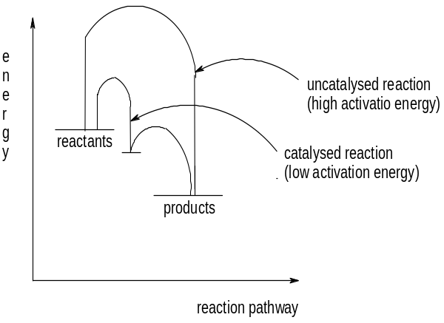

Because the activation energy is lower, more particles have enough energy to react when they collide and so the fraction of successful collisions is higher.

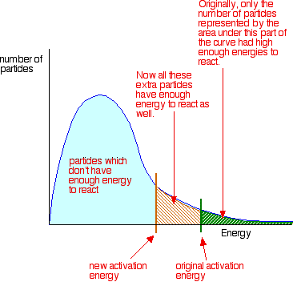

- Homogeneous catalysis

A homogeneous catalyst is a catalyst in the same phase as the reactants.

Homogeneous catalysis involves aqueous transition metal ions catalysing reactions, often between two anions. The cation reacts with each anion in turn, thus avoiding the need for a direct collision between two anions (this is difficult since they repel each other).

Eg 1 S₂O₈²⁻(aq) + 2I⁻(aq) → 2SO₄²⁻(aq) + I₂(aq)

This can be catalysed by Fe²⁺ or Fe³⁺ ions:

With Fe²⁺: S₂O₈²⁻(aq) + 2Fe²⁺(aq) → 2SO₄²⁻(aq) + 2Fe³⁺(aq)
2Fe³⁺(aq) + 2I⁻(aq) → 2Fe²⁺(aq) + I₂(aq)

With Fe³⁺: 2Fe³⁺(aq) + 2I⁻(aq) → 2Fe²⁺(aq) + I₂(aq)
2Fe²⁺(aq) + S₂O₈²⁻(aq) → 2Fe³⁺(aq) + 2SO₄²⁻(aq)

Eg 2 2MnO₄⁻(aq) + 5C₂O₄²⁻(aq) + 16H⁺(aq) → 2Mn²⁺(aq) + 10CO₂(g) + 8H₂O(l)

This is a good example of auto-catalysis.

One of the products in this reaction, Mn²⁺(aq), behaves as a catalyst and thus the reaction is slow at first but is much faster after a little of the products are formed.

- Heterogeneous catalysis

Heterogeneous catalysts react by allowing the reactant molecules to bond to the surface of the metal, usually by attracting the surface electrons. The reaction takes place at the surface, and the transition metal regains electrons as the products leave. The reaction is catalysed because the reactant molecules spend more time in contact with each other than they would in the absence of a catalyst.

Eg hydrogenation of ethene

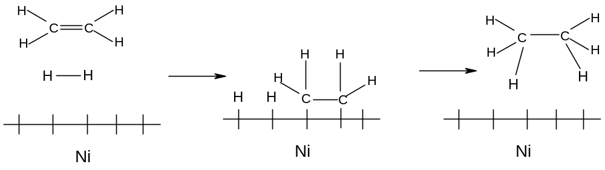

a) physical adsorption and chemisorption

The molecules usually bond to the surface of the metal using intermolecular forces such as Van der Waal’s forces. This is known as physical adsorption. Sometimes they actually form a covalent bond with the metal. This is known as chemisorption.

An ideal heterogeneous catalyst adsorbs fairly strongly but not too strongly. If it adsorbs too weakly (like silver) the reactant molecules do not spend enough time in contact with each other. If they adsorb too strongly (like tungsten) the products do not leave the metal surface quickly enough and this slows the reaction down.

The most useful catalysts are those which adsorb moderately. As the strength of absorption tends to decrease fro left to right along the Periodic Table, the most effective catalysts tend to be the transition metals in the middle, like V, Fe and Ni.

b) examples of heterogeneous catalysts

Examples of heterogenous catalysts are; Fe in the production of ammonia, V₂O₅ in the contact process and Pt or Ni in the hydrogenation of ethene.

i) N₂(g) + 3H₂(g) == 2NH₃(g) Fe catalyst

ii) 2SO₂(g) + O₂(g) == 2SO₃(g) V₂O₅ catalyst

iii) C₂H₄(g) + H₂(g) == C₂H₆(g) Pt/Ni catalyst

iv) 2CO(g) + 2NO(g) == N₂(g) + 2CO₂(g) Rh catalyst
The catalytic converter converts toxic carbon monoxide and nitrogen monoxide to non-toxic carbon dioxide and nitrogen.

c) surface area

The catalyst needs to have a large surface area to be effective. This means it needs to be very thinly spread out, and might need a special support.
Catalytic converters in cars use rhodium (Rh) on a special ceramic support

d) catalyst poisoning

Heterogeneous catalysts can be poisoned by impurities, which are often present in the raw materials used. These impurities bond very strongly to the catalyst surface and block it.

The activity of iron in the Haber process is reduced by sulphur, present in iron as an impurity so it is essential that as much sulphur as possible is removed during the Basic Oxygen Process.

The efficiency of catalytic converters in cars is reduced by lead, which bonds permanently to the rhodium surface. This has lead to the increased use of unleaded petrol.

REDOX CHEMISTRY OF SOME TRANSITION ELEMENTS

Since transition metals show a variety of transition states in their compounds, much of their chemistry is dominated by movement between these transition states.
When the oxidation state changes, the colour changes as the electron distribution in the d-orbitals is different.
The colour is also affected by the ligands involved, as the type of ligand affects the amount of splitting in the d-orbitals.

1. Iron

Iron exists in two common oxidation states, +2 (Fe²⁺) and +3 (Fe³⁺).
In aqueous solution, the Fe is readily oxidised from Fe²⁺ to Fe³⁺:
Fe²⁺(aq) → Fe³⁺(aq) + e

The Fe²⁺ ion is thus a reducing agent. Concentrations of Fe³⁺ in solution can be determined by titration with oxidising agents.

2. Manganese

Manganese can exist in a number of oxidation states, but is most stable in an oxidation state of +2, +4 or +7

In the +7 oxidation state it exists as the intense purple ion MnO₄⁻. This can be reduced to the pale pink Mn²⁺ by Fe²⁺ in acidic solution:

MnO₄⁻(aq) + 8H⁻(aq) + 5e → Mn²⁺(aq) + 4H₂O(l)
Fe²⁺(aq) → Fe³⁺(aq) + e
Overall: MnO₄⁻(aq) + 8H⁺(aq) + 5Fe²⁺(aq) → Mn²⁺(aq) + 4H₂O(l) + 5Fe³⁺(aq)

3. Vanadium

Vanadium forms stable compounds in 4 different oxidation states, +2, +3, +4 and +5.

In aqueous solution, the ions formed are:

Oxidation state | +5 | +4 | +3 | +2
Colour | Yellow | Blue | green | Violet
Ion | VO₂⁺ | VO²⁺ | V³⁺ | V²⁺

All vanadium (V) compounds can be reduced to the +4, +3 and then +2 oxidation state by strong reducing agents such as zinc in acid solution:
VO₂⁺(aq) + 4H⁺(aq) + 3e → V²⁺(aq) + 2H₂O(l)
Zn(s) → Zn²⁺(aq) + 2e

Overall: 2VO₂⁺(aq) + 8H⁺(aq) + 3Zn(s) → 2V²⁺(aq) + 3Zn²⁺(aq) + 4H₂O(l)
Yellow violet

The reaction proceeds via the +4 and +3 oxidation states, so the colour change observed is yellow(VO₂⁺) → green (VO₂⁺ and VO²⁺) → blue (VO²⁺) → green (V³⁺) → violet (V²⁺).

Other, milder reducing agents will reduce the +5 oxidation state to +4 but no further.

If exposed to air, the violet +2 complex will slowly oxidize to the green +3 complex.

The precise colours of the solutions will depend on the acids used. Cl⁻ ions can behave as ligands and this will affect the colour.

Eg if HCl is the acid, the +3 complex is [V(H₂O)₄Cl₂]⁺, which is green, but if H₂SO₄ is used, the +3 complex is [V(H₂O)₆]³⁺, which is grey-blue. So the colour of the complexes depends both on the oxidation state and the nature of the different ligands in solution.

4. Chromium

Chromium forms stable ions in three different oxidation states, +2, +3 and +6.

In aqueous solutions, the ions formed are:

Oxidation state | +6 | +3 | +2
Colour | orange | Green | blue
Ion | Cr₂O₇²⁻ | Cr³⁺ | Cr²⁺

The actual formula of the +2 and +3 complex ions depends on the acid used (Cl⁻ and SO₄²⁻ will also behave as ligands).

In aqueous alkaline solutions, the ions formed are:

Oxidation state | +6 | +3
Colour | yellow | Green
Ion | CrO₄²⁻ | Cr(OH)₆³⁻

The +6 chromium complexes can be readily interconverted using acid and alkali:

2CrO₄²⁻(aq) + 2H⁺(aq) → Cr₂O₇²⁻(aq) + H₂O(l)
Cr₂O₇²⁻(aq) + 2OH⁻(aq) → 2CrO₄²⁻(aq) + H₂O(l)

a) In acidic solution

All chromium (VI) compounds can be reduced to the +3 and then the +2 oxidation state by strong reducing agents such as zinc in acid solution.

The chromium is first reduced to the +3 oxidation state:
Cr₂O₇²⁻(aq) + 14H⁺(aq) + 6e == 2Cr³⁺(aq) + 7H₂O(l)
Zn(s) == Zn²⁺(aq) + 2e
Overall : Cr₂O₇²⁻(aq) + 14H⁺(aq) + 3Zn(s) → 2Cr³⁺(aq) + 7H₂O(l) + 3Zn²⁺(aq)

It is then further reduced:
Cr³⁺(aq) + e == Cr²⁺(aq)
Zn(s) == Zn²⁺(aq) + 2e
Overall: Zn(s) + 2Cr³⁺(aq) → Zn²⁺(aq) + 2Cr²⁺(aq)

The colour change observed on adding zinc in acid solution to dichromate ions is orange (Cr₂O₇²⁻) to green (Cr³⁺) to blue (Cr²⁺).

Other, milder reducing agents will reduce the +6 oxidation state to +3 but no further.
Fe²⁺ is an important example:

Fe²⁺(aq) == Fe³⁺(aq) + e
Overall: Cr₂O₇²⁻(aq) + 14H⁺(aq) + 6Fe²⁺(aq) → 2Cr³⁺(aq) + 7H₂O(l) + 6Fe³⁺(aq)

This reaction can be used in titrations to determine the concentration of Fe²⁺ ions in a sample.

b) In alkaline solution

In alkaline solution, it is possible to oxidise the +3 oxidation state to the +6 oxidation state.
The chromium ion forms the [Cr(OH)₆]³⁻ complex in alkaline conditions. This complex can be oxidized to the +6 oxidation state by adding H₂O₂. Hydrogen peroxide, which is a reducing agent in acidic solution, is an oxidizing agent in alkaline solution.

[Cr(OH)₆]³⁻(aq) + 2OH⁻(aq) == CrO₄²⁻(aq) + 4H₂O(l) + 3e
H₂O₂(aq) + 2e == 2OH⁻(aq)
2[Cr(OH)₆]³⁻(aq) + 3H₂O₂(aq) → 2CrO₄²⁻(aq) + 8H₂O(l) + 2OH⁻(aq)

The green [Cr(OH)₆]³⁻ ion is oxidised to the yellow CrO₄²⁻ ion in alkaline solution.

The relative tendency of species to undergo oxidation and reduction often depends dramatically on the pH of the solution. The interconversion of the chromium (III) and chromium (VI) oxidation states is an important example.

In general, oxidation is favoured by alkaline conditions and reduction is favoured by acidic conditions.

5. Cobalt

Cobalt exists in two stable oxidation states, +2 and +3

In acidic or neutral solution:

Oxidation state | +3 | +2
Colour | yellow | Pink
Ion | Co³⁺ | Co²⁺

In alkaline solution:

Oxidation state | +3 | +2
Colour | brown | Blue
Compound | Co(OH)₃ | Co(OH)₂

In ammonia solution:

Oxidation state | +3 | +2
Colour | brown | Straw
Ion | Co(NH₃)₆³⁺ | Co(NH₃)₆²⁺

The colours of these complexes are not easy to identify as they change colour readily depending on the concentration of the various species in solution.

The ease of oxidation of cobalt from +2 to +3 depends on the ligand and the pH:

- It is extremely difficult to oxidise cobalt from +2 to +3 in acidic solution.

- It is easier to oxidise Co²⁺ in alkaline solution using hydrogen peroxide. The blue Co(OH)₂ is oxidized to brown Co(OH)₃:

Co(OH)₂(s) + OH⁻(aq) == Co(OH)₃(s) + e
H₂O₂(aq) + 2e == 2OH⁻(aq)
Overall: 2Co(OH)₂(s) + H₂O₂(aq) → 2Co(OH)₃(s)

- In ammoniacal solution it is very easy to oxidise Co²⁺, and it is oxidized when left to stand in air. The straw Co(NH₃)₆²⁺ is oxidised to the brown Co(NH₃)₆³⁺ (the solution gets darker):

Co(NH₃)₆²⁺(aq) == Co(NH₃)₆³⁺(aq) + e
O₂(g) + 2H₂O(l) + 4e → 4OH⁻(aq)
Overall: 4Co(NH₃)₆²⁺(aq) + O₂(g) + 2H₂O(l) → 4Co(NH₃)₆³⁺(aq) + 4OH⁻(aq)

REDOX TITRATIONS INVOLVING TRANSITION METALS

Oxidising agents in aqueous solution can be determined by titrating against standard solutions of reducing agents. Reducing agents in aqueous solution can be determined by titrating against standard solutions of oxidising agents.

In the laboratory, there are two important reagents involving transition metals that are used in these titrations: potassium manganate (VII), KMnO₄, and potassium dichromate, K₂Cr₂O₇.

The procedures and principles involved in these titrations will be considered in turn:

- Potassium manganate (VII) (KMnO₄) titrations.

The MnO₄⁻ ion is a powerful oxidising agent:
MnO₄⁻(aq) + 8H⁺(aq) + 5e → Mn²⁺(aq) + 4H₂O(l)

It can therefore be used to determine reducing agents.

The most important principles involved in titrations involving KMnO₄ are:

- The colour change associated with the above reduction is:
MnO₄⁻ (intense purple) → Mn²⁺ (colourless)
The colour change is so intense that no indicator is required for the reaction.

- The KMnO₄ solution is generally placed in the burette. This causes two problems:

- the intense colour of KMnO₄ means that it is very difficult to see the graduation marks on the burette, and so it is difficult to read accurately.
- The KMnO₄ reacts slightly with the glass, causing a slight stain if the burette is used too often.

The reason the KMnO₄ is placed in the burette is as follows:
As the KMnO₄ is added to the solution under investigation, it is immediately decolorised by the reducing agent. The end-point is detected by the failure of the purple colour to disappear - a pink colour persists in the conical flask, indicating that the MnO₄⁻ ions are no longer being reduced. This permanent pink colour is easily detected.

If the KMnO₄ were in the conical flask, it would slowly decolorise until the solution became completely colourless. The gradual disappearance of the pink colour is much harder to detect than the sudden appearance of the pink colour, and for this reason the KMnO₄ is always placed in the burette, despite the difficulties it presents in reading the burette.

- Since the MnO₄⁻ ion is only an effective oxidising agent in acidic medium, it is necessary to add excess acid to the conical flask before carrying out the titration.
Sulphuric acid is generally used for this purpose. Hydrochloric acid should not be used since it is a reducing agent and will react with the MnO₄⁻ before the MnO₄⁻ can react with the reducing agent under investigation:

MnO₄⁻ (aq) + 8H⁺(aq) + 5Cl⁻ → Mn²⁺(aq) + 4H₂O(l) + 21/2Cl₂(g)

Common examples of reducing agents which are determined using KMnO₄ are Fe²⁺(aq) and C₂O₄²⁻(aq)
Fe²⁺(aq) → Fe³⁺(aq) + e , C₂O₄²⁻(aq) → 2CO₂(g) + 2e
MnO₄⁻ (aq) + 8H⁺(aq) + 5Fe²⁺(aq)→ Mn²⁺(aq) + 4H₂O(l) + 5Fe³⁺(aq)
2MnO₄⁻ (aq) + 16H⁺(aq) + 5C₂O₄²⁻(aq)→ 2Mn²⁺(aq) + 8H₂O(l) + 10CO₂(g)

- Potassium dichromate (VI) (K₂Cr₂O₇) titrations

Potassium dichromate (VI) is also a good oxidising agent in acidic medium:
Cr₂O₇²⁻(aq) + 14H⁺(aq) + 6e == 2Cr³⁺(aq) + 7H₂O(l)

It can therefore be used to determine reducing agents.

The most important principles of potassium dichromate titrations are:

- The colour change associated with this titration is orange → green. The colours are not, however, as intense as with the manganate titration and an indicator is needed. Diphenylaminesulphonate is used. It turns from colourless to purple at the end-point.

- The dichromate is always placed in the burette as it is easier to see the appearance of the purple colour than its disappearance.

- As with manganate, care must be taken as to which acid to use. Sulphuric acid should be used as chloride ions could interfere with the titration.

Fe²⁺(aq) is the reducing agent most commonly determined by titration with potassium dichromate (VI).
Fe²⁺(aq) == Fe³⁺(aq) + e
Cr₂O₇²⁻(aq) + 14H⁺(aq) + 6Fe²⁺(aq) → 2Cr³⁺(aq) + 7H₂O(l) + 6Fe³⁺(aq)

